OPERATING SYSTEMS
ASSIGNMENT 3 (CO3)
CO3: Evaluate memory-management mechanisms such as linking, paging, segmentation, virtual memory, demand paging, page-replacement techniques and disk management.
Nature of Assignment: Individual
Duration: 1 Week
Total Marks: 50
Submission Date:3-11-2026
Bloom’s Levels Assessed: K5 – Evaluate (every task in this assignment is at K5 level)
Mandatory Execution and GitHub Submission
- Every student must individually execute every task in this assignment, including all “Complete the Code” programs.
- Create a GitHub repository named CSA04-<RegisterNumber>-Assignment3 and share it with the course faculty (public, or private with the faculty added as a collaborator).
- Keep one folder for each task (for example: Task01, Task02 … or Q1, Q2 …), containing the C source files, shell scripts, configuration files (Dockerfile, YAML), command outputs and screenshots.
- Include a README.md with your name, register number, compiler and version (for example gcc 13), the Linux distribution and version used, the exact gcc command used to compile (for example gcc -std=c11 -Wall -Wextra -pthread), the steps to run each program, and a short note of the result of each task.
- Commit your work progressively – at least one commit for each task. The commit history will be checked; a single upload of all files on the last day will not be accepted.
- Submit the GitHub link below and on the cover page of your report. An assignment submitted without a working GitHub link will not be evaluated.

GitHub Repository Link:
How to Answer the Additional Questions
Complete the Code: Copy the given code into your repository, replace every TODO with working code without changing the rest of the program, execute it and compare your output (or result) with the expected output.
Alternative Concept and Complexity Analysis: Describe how the solution would change if the alternative concept were used, with code or pseudocode, and analyse and compare the time complexity and space complexity of both solutions using Big-O notation, supported by your own measurements wherever possible.
Assignment Principle
Every question asks you to design, implement, analyse and evaluate the solution yourself, so that you demonstrate evidence of:
Design → Implementation → Analysis → Evaluation

Q1. Linking, Loading and Address Binding (6 Marks)
1. Static Linking
Static linking combines all required library code with the program during compilation.
- Produces a larger executable file.
- Does not require external libraries at runtime.
- Updating a library requires recompiling the program.
- Uses more disk space.
2. Dynamic Linking
Dynamic linking connects the program to shared libraries at runtime.
- Produces a smaller executable.
- Multiple programs can share the same library in memory.
- Libraries can be updated without recompiling the program.
- The required shared library must be available.
3. Address Binding
- Compile-time binding: Physical address is decided during compilation.
- Load-time binding: Address is decided when the program is loaded.
- Execution-time binding: Address can change while the program is running.
4. Linker and Loader
- Linker combines object files and libraries.
- Loader loads the program into main memory and starts execution.
5. Position Independent Code (PIC)
PIC is code that can execute from different memory locations without modification. It is commonly used in shared libraries.
6. Comparison
Static linking | Dynamic linking
Large executable | Small executable
More disk space | Less disk space
Easy to run independently | Requires shared libraries
Updating requires recompilation | Library can be updated separately
Conclusion: Dynamic linking is better for the bank because the encryption library can be updated without rebuilding the complete application.
Alternative Concept – Runtime Linking
Using dlopen() and dlsym(), the program can load the encryption library only when required.
- Reduces memory use when encryption is not needed.
- Can reduce startup time.
- The program must handle errors if the library is missing.
- It is useful when a library is required only occasionally.
Q2. Paging (8 Marks)
1. Meaning of Paging
Paging is a memory-management technique that divides logical memory into fixed-size blocks called pages and physical memory into blocks called frames.
2. External Fragmentation
External fragmentation occurs when free memory is divided into small gaps. A large process may not fit into one continuous block even when enough total memory is available.
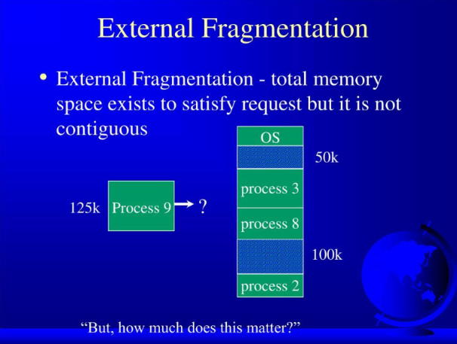

3. Address Translation
Formula:
- Page number = Logical address / Page size
- Offset = Logical address % Page size
- Physical address = Frame number × Page size + Offset
Given page size = 1024 bytes.
Logical address | Page | Offset | Result
0 | 0 | 0 | 5120
1500 | 1 | 476 | 2524
3100 | 3 | 28 | 7196
6200 | 6 | 56 | 3128
9000 | 8 | 808 | Invalid address
2049 | 2 | 1 | Page fault
4. Page Table Size
Assuming each page-table entry uses 4 bytes:
- 32-bit address space with 4 KB pages: \(2^{32}/2^{12}=2^{20}\) entries.
- Size = \(2^{20}\times4\) = 4 MB.
- 48-bit address space with 4 KB pages: \(2^{48}/2^{12}=2^{36}\) entries.
- Size = \(2^{36}\times4\) = 256 GB.
5. TLB
TLB (Translation Lookaside Buffer) stores recently used page-table entries. It reduces address-translation time.
6. Page Sizes
- 1 KB: Less internal fragmentation, but larger page tables.
- 4 KB: Balanced memory usage and performance.
- 2 MB: Smaller page tables, but more internal fragmentation.
7. Types of Page Tables
- Multi-level page table: Divides the page table into levels.
- Hashed page table: Uses hashing to find page entries.
- Inverted page table: Maintains one entry for each physical frame.
8. Protection and Shared Pages
Paging provides read, write and execute permissions. Shared pages allow multiple processes to use the same physical memory.
Conclusion: A 4 KB page size is a suitable choice for a college server because it provides a balance between memory usage and page-table size.
Complete the Code – Q2
#include <stdio.h>

#define PAGE_SIZE 1024
#define PAGES 8

int page_table[PAGES] = {5, 2, -1, 7, 0, -1, 3, -1};

int main(void)
{
unsigned logical[] = {0, 1500, 3100, 6200, 9000, 2049};

for (int i = 0; i < 6; i++) {
unsigned a = logical[i];
unsigned p = a / PAGE_SIZE;
unsigned d = a % PAGE_SIZE;

printf("%5u -> page %u offset %6u : ", a, p, d);

if (p >= PAGES)
printf("invalid address\n");
else if (page_table[p] == -1)
printf("page fault\n");
else
printf("physical %u\n",
page_table[p] * PAGE_SIZE + d);
}

return 0;
}
Alternative Concept – Inverted Page Table
An inverted page table contains one entry for each physical frame instead of maintaining a separate page table for every process.
- Uses less memory for large address spaces.
- Requires searching or hashing to find the required page.
- A normal multi-level page table may need several levels of lookup.
- An inverted page table is useful when many processes have large virtual address spaces.
Q3. Segmentation (6 Marks)
1. Meaning of Segmentation
Segmentation divides a program into logical parts called segments.
Examples:
- Code segment
- Data segment
- Stack segment
- Heap segment
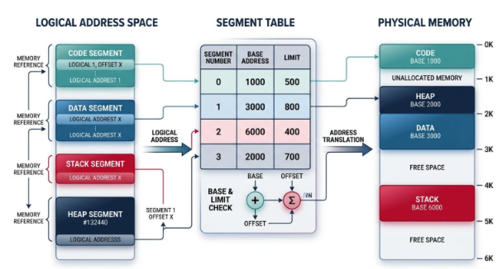
2. Address Translation
A logical address contains:
- Segment number
- Offset
Formula:
Physical address = Base address + Offset
The offset must be less than the segment limit.
Example:
Segment | Base | Limit
Code | 1000 | 500
Data | 2000 | 300
Stack | 3000 | 400
For code segment offset 200:
Physical address = 1000 + 200 = 1200
For data segment offset 350:
Since 350 is greater than the limit 300, a segmentation fault occurs.
3. Protection and Sharing
- Code segments can be read-only.
- Data segments can have read and write permissions.
- Common code can be shared by multiple processes.
4. External Fragmentation
Segmentation may create small free memory spaces between segments. This is called external fragmentation.
5. Comparison
Method | Explanation
Paging | Divides memory into fixed-size pages
Segmentation | Divides memory into logical segments
Segmented paging | Uses both segmentation and paging
6. Segmentation with Paging
First, the segment table identifies the page table. Then paging translates the page number into a physical frame.
Conclusion: Modern operating systems mainly use paging because it avoids external fragmentation and manages memory efficiently.
Alternative Concept – Pure Paging
If pure paging is used:
- Memory is divided into fixed-size pages.
- External fragmentation is removed.
- Internal fragmentation may occur.
- Page tables are required.
- Sharing and protection are managed using page-table permissions.
Q4. Virtual Memory and Demand Paging (8 Marks)
1. Virtual Memory
Virtual memory allows a program to run even when its complete size is larger than the available RAM.
Example: A program requires 24 GB memory, but the laptop has only 16 GB RAM.
The operating system keeps required pages in RAM and moves other pages to storage when necessary.
2. Demand Paging
Demand paging loads a page into memory only when the program needs it.
3. Steps in Handling a Page Fault
- CPU requests a page.
- Operating system checks the page table.
- If the page is missing, a page fault occurs.
- OS finds the required page on storage.
- A free frame is selected.
- The page is loaded into RAM.
- The page table is updated.
- The program continues execution.
- 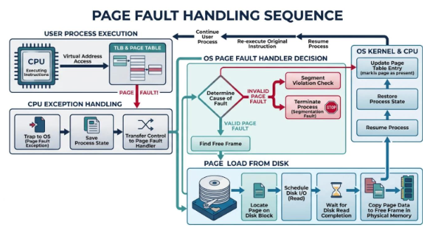
4. Effective Access Time Calculation
Given:
- Memory access time = 100 ns
- Page fault service time = 8 ms = 8,000,000 ns
Formula:
\[ EAT=(1-p)\times100+p\times8,000,000 \]
Page fault rate | Effective access time
1 in 1,000 | 8099.9 ns
1 in 100,000 | 179.999 ns
1 in 1,000,000 | 107.9999 ns
5. Copy-on-Write
Copy-on-Write allows parent and child processes to share the same memory pages after fork().
A separate copy is created only when one process modifies a shared page. This makes process creation faster.
6. Thrashing
Thrashing occurs when the system spends more time transferring pages between RAM and disk than executing programs.
7. Working-Set Model
The working-set model identifies the pages a process actively uses during a particular period. It helps decide how many frames a process needs.
8. Frame Allocation
- Equal allocation: Each process receives an equal number of frames.
- Proportional allocation: Frames are allocated according to the size of each process.
Conclusion: Improving the program's memory locality is important. However, increasing RAM to 32 GB is a better solution if the radiologist regularly needs the full 24 GB, because it reduces page faults and improves performance.
Alternative Concept – 32 GB RAM
With 32 GB RAM, the complete 24 GB program can fit in physical memory, reducing the need for demand paging.
- Fewer page faults.
- Faster program execution.
- Higher hardware cost.
- Better performance for large imaging applications.
Q5. Page-Replacement Techniques (8 Marks)
1. Meaning
Page replacement is a technique used by the operating system to select which page should be removed when memory is full.
2. FIFO (First In First Out)
FIFO removes the page that entered memory first.
3. LRU (Least Recently Used)
LRU removes the page that has not been used for the longest time.
4. Optimal Page Replacement
Optimal removes the page that will not be used for the longest time in the future.
5. Comparison
Algorithm | Working
FIFO | Removes oldest page
LRU | Removes least recently used page
Optimal | Removes page needed farthest in future
6. Expected Output
Frames | FIFO | LRU | Optimal
3 | 15 | 12 | 9
4 | 10 | 8 | 8
Belady's anomaly using FIFO:
- 3 frames = 9 page faults
- 4 frames = 10 page faults
7. Belady's Anomaly
Belady's anomaly occurs when increasing the number of frames increases the number of page faults. FIFO can show this problem.
LRU does not suffer from Belady's anomaly because it follows the stack property.
8. Clock Algorithm
The clock algorithm is a practical approximation of LRU. It uses a reference bit to identify pages that have been recently used.
Conclusion: LRU is a good choice for a web server because it uses recent page usage to make replacement decisions. The clock algorithm is also useful because it requires less overhead.
Complete the Code – Q5 (LRU)
Replace the TODO section in the given program with:
if (used < frames) {
f[used] = ref[i];
last[used] = i;
used++;
}
else {
int victim = 0;

for (int j = 1; j < frames; j++) {
if (last[j] < last[victim]) {
victim = j;
}
}

f[victim] = ref[i];
last[victim] = i;
}
Alternative Concept – Clock Algorithm
- Exact LRU updates the usage information on every page access.
- Clock uses a reference bit for each frame.
- Clock requires less overhead.
- LRU may give fewer page faults, but clock is simpler to implement.
Q6. Disk Management (4 Marks)
1. Disk Formatting
Disk formatting prepares a disk for storing data.
Types:
- Low-level formatting: Divides the disk into sectors.
- Partitioning: Divides the disk into separate sections.
- Logical formatting: Creates a file system such as ext4.
2. Boot Block
A boot block contains the information needed to start the operating system.
Boot process:
- Computer starts.
- BIOS or UEFI runs.
- Bootloader loads.
- Operating system kernel starts.
- System services are started.
3. Bad Blocks
Bad blocks are damaged disk sectors. The operating system or disk controller identifies and avoids using them.
4. Swap Space
Swap space is storage used as additional virtual memory when RAM is insufficient.
It can be created as:
- A separate swap partition.
- A swap file.
5. RAID Comparison
RAID | Capacity (6 × 4 TB) | Reliability
RAID 0 | 24 TB | No protection
RAID 1 | 12 TB | Can survive one failure in each mirror pair
RAID 5 | 20 TB | Can survive one disk failure
RAID 10 | 12 TB | Can survive one failure in each mirror pair
6. RAID 6 Alternative
RAID 6 uses double parity.
- Capacity = (6 − 2) × 4 TB = 16 TB.
- Can survive two disk failures.
- Writing data requires extra parity calculations.
- Provides better protection than RAID 5.
7. Linux Commands
To view disk partitions:
lsblk
To display partition information:
sudo fdisk -l
To view swap:
swapon --show
Conclusion: RAID 6 is a good choice for a hospital records server because it can survive two disk failures. Regular backups are also necessary.
Q7. Design a Memory-Management Plan from First Principles (10 Marks)
Problem: A smart factory uses edge devices with 2 GB RAM and no swap space.
It runs three tasks:
- Real-time control task.
- Machine-learning task requiring 1.5 GB.
- Logging task.
Stage 1 – Understand the Problem
- Real-time task needs fast and predictable memory access.
- Machine-learning task requires large memory.
- Logging task stores system information.
- Real-time task must not experience page faults.
- Machine-learning and logging tasks can tolerate some delays.
Requirements:
- Total RAM = 2 GB.
- Machine-learning memory requirement = 1.5 GB.
- Real-time task memory should remain locked.
- No swap space is available.
Stage 2 – Compare Memory Management Methods
Method | Advantage | Disadvantage
Contiguous allocation | Simple | External fragmentation
Paging | Efficient memory usage | Page faults may occur
Segmentation | Logical memory division | External fragmentation
Demand paging | Loads pages when required | Page-fault delay
Recommended method:
- Use locked memory for the real-time task.
- Use paging for machine-learning tasks.
- Use limited memory for logging.
- Keep enough free memory for system operations.
Stage 3 – Implement and Verify
The following C program locks memory using mlock().
#include <stdio.h>
#include <stdlib.h>
#include <sys/mman.h>
#include <time.h>

int main(void)
{
size_t size = 1024 * 1024;

char *memory = malloc(size);

if (memory == NULL) {
printf("Memory allocation failed\n");
return 1;
}

if (mlock(memory, size) == 0)
printf("Memory locked successfully\n");
else
perror("mlock");

for (size_t i = 0; i < size; i++)
memory[i] = 0;

printf("Real-time memory task completed\n");

munlock(memory, size);
free(memory);

return 0;
}
Compile and execute:
gcc -std=c11 -Wall -Wextra memory.c -o memory
./memory
Expected output when memory locking is permitted:
Memory locked successfully
Real-time memory task completed
Note: If memory locking fails, check the system's memory-locking limit and permissions. This sample demonstrates memory locking; actual worst-case delay measurements must be collected by running the program on your system.
Stage 4 – Defend the Design
- Locked memory prevents the real-time task's locked pages from being swapped out.
- Paging allows flexible memory allocation.
- Machine-learning tasks can use memory in smaller portions.
- Logging should use limited memory.
- If a fourth task of 500 MB is added, memory usage must be reviewed and tasks may need to share resources or use a more powerful device.
- One limitation is that 2 GB RAM may not be sufficient for all tasks.
Alternative Concept – Real-Time Operating System
If an RTOS without virtual memory is used:
- Real-time task gets predictable memory access.
- Page faults are avoided.
- Machine-learning memory must fit within available RAM.
- Adding new tasks requires careful memory planning.
- It provides better timing control but less flexibility than Linux virtual memory.
Conclusion: A combination of locked memory for real-time tasks and paging for other tasks is suitable for the smart factory. A real-time operating system is another good choice when strict timing guarantees are required.
MARK DISTRIBUTION

Question | Assessed Area | Bloom’s Level | Marks
Q1 | Linking, loading and address binding | K5 – Evaluate | 6
Q2 | Paging | K5 – Evaluate | 8
Q3 | Segmentation | K5 – Evaluate | 6
Q4 | Virtual memory and demand paging | K5 – Evaluate | 8
Q5 | Page-replacement techniques | K5 – Evaluate | 8
Q6 | Disk management | K5 – Evaluate | 4
Q7 | Memory-management plan from first principles | K5 – Evaluate | 10
 | TOTAL |  | 50

